

Spectral Forest
tEEm Radiance
Benjamin Reed, Hayden O’Reilly, Manolo Ortiz | Project Design Procedures
November 30, 2023

Introduction
The health and diversity of plants in a forest can be determined by the condition of the forest, which can also serve as an indication of plant diseases and fire hazards. However, traditional methods of measuring forest health can be cumbersome, time-consuming, and require significant labor. While there have been previous efforts made to observe the health of the forest canopy, the understory is often overlooked. This highlights the need for a system that can evaluate forest health with minimal effort and waiting time.
Our project seeks to utilize the measurement of wavelengths of light in determining various conditions of the health and well-being of the forest understory such as plant health, species differentiation, and subtle environmental changes specific to the understory. While other spectrometers exist on the market that can be used in a more “local” setting and can measure light in similar ways, our design hopes to be able to run for extended periods of time within more remote locations. Our team consists of Benjamin Reed (Team Lead), Manolo Ortiz (Treasurer), and Hayden O’Reilly (Secretary), working alongside Dr. Alexander Shenkin.

Problem Statement
[NEEDS] The condition and diversity of plants can be determined by the health of the forest, which can be indicators of plant disease and fire dangers. Measuring the health of forests using traditional methods can be a tedious, time-consuming, and labor-intensive process. There is a need for a system that can evaluate the health of forests that are less labor-intensive with minimal waiting time.
[Objective] The objective of this project is to create and test a device capable of assessing the overall health of forests. The device will allow researchers to capture and save spectral image wavelengths that can be used to determine the well-being of plants and trees. With remote data-capturing capabilities, the device will eliminate the need for physical presence during data collection.

Objective Tree
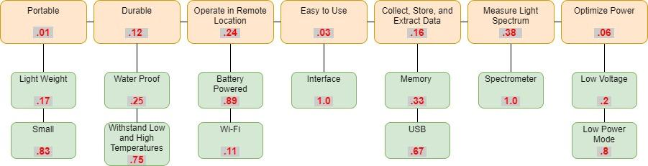
Figure 1: The Objective Tree illustrates the marketing requirements for the project, with red values representing weights.

System Requirements
TECHNICAL AND FUNCTIONAL REQUIREMENTS
- The Spectral Forest SWIR spectrometer will:
- Accurately gather Near Infrared (NIR) wavelengths from 350 nm to 1000 nm on at least one linear array. *We may potentially extend the spectral range of the unit with additional photo sensors.
- Deliver hyperspectral responsivity in the 350 nm to 1000 nm spectrum.
- Provide efficient means for data acquisition, processing, and retrieval.
- Have a microSD card slot for expandable memory capability.
- Connect an externally accessible USB 2.0 port to the interface and charge unit without opening the box.
- Design spectrometer electronics to be seamlessly integrated with a custom-tailored PCB.
- Be built into a weatherproof box designed by the ME team.
- Optimize space, footprint, and PCB geometry to integrate into the hermetic enclosure.
- The device will work off-grid, powered by a 12V battery.
- The device will run for as long as possible by incorporating advanced strategies for power conservation.
- Allow for supplemental power when the device is deployed on the ground, via detachable solar panel.
- There will be a multi-color LED to indicate functionality, various states of the device, and error conditions.
- Be deployable in a stationary or mobile deployment on the ground, as well as by air attached to an Unmanned Aerial Vehicle (UAV) for spectral analysis of the forest canopy and the forest floor.
HARDWARE, SOFTWARE, AND PERFORMANCE REQUIREMENTS
- The Spectral Forest SWIR Spectrometer will:
- Run a microcontroller via MicroPython to integrate with the linear array and optimize memory usage as well as power conservation.
- Have custom-designed and ruggedly designed compact PCB to run the MCU and Photonic Integrated Circuit (PIC).
- Run as long as possible off battery power for a minimum of five days.
- Can charge while running.
- Collect supplemental power through a solar panel.
- Be capable of mobile and stationary data collection and processing.
- Log time and date.
- Be able to perform optimally in the full range of weather conditions in Flagstaff and beyond.
- Incorporate additional sensors to log:
- Humidity.
- Temperature.
- Barometric Pressure.
- Angle of light collection relative to horizon.
- Have a controllable sample period.
- Have an auto-tunable sample period.
- Allow for controllable duration between samples.
- Allow for ease of data collection with USB 2.0 connection. Be programmed with embedded analytics like air density.
- Be calibratable.
- Be accurate and operational within the intended range of functionality.

ENGINEERING TRADE-OFF MATRIX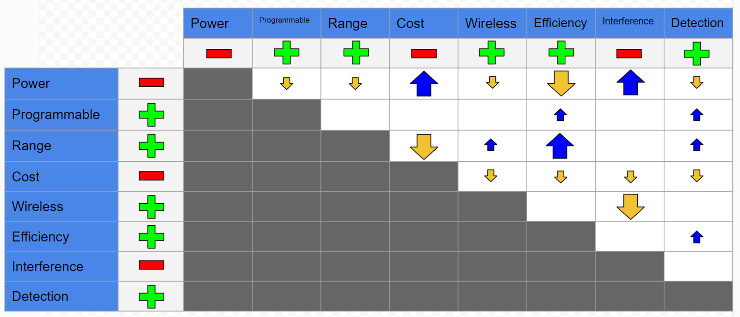
Figure 2 : The engineering trade-off matrix.
The Engineering Requirements compared are relative to how the overall design would be affected by each. Interference refers to both interference of the design of the Mechanical Team (which we want low) as well as the Compatibility of the design with the Mechanical Team (which we want high); Interference is the term used, so the polarity is negative. Low power is generally a restriction to everything but cost and potential electrical interference, while low cost generally isn’t conducive to anything other than low power. A high range chip, programmability, and error detection provided the highest advantage to disadvantage ratio.

ENGINEERING-MARKETING TRADE-OFF MATRIX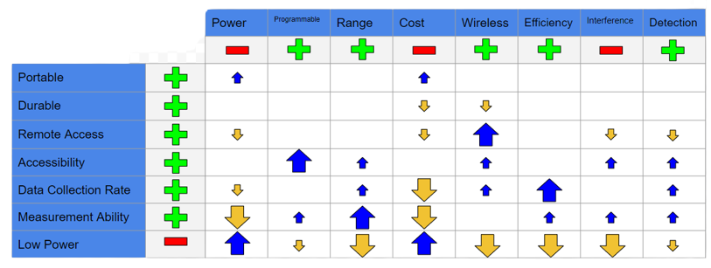
Figure 3: The engineering-marketing trade off matrix.
Once again, low power caused the most restrictions of any other requirement. Measurement Ability and Range went hand in hand with each other. Based upon the comparison, Accessibility appears to coincide the most with the engineering requirements. None of the marketing requirements seem to provide too many issues, other than low power and, to an extent, measurement ability (the ability to measure the visible light spectrum and beyond).
HOUSE-OF-QUALITY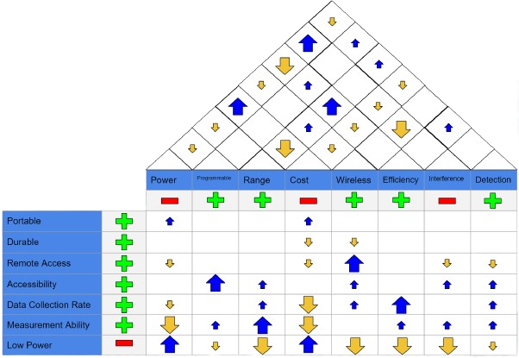
Figure 4 : The House-Of-Quality Matrix.
The House of Quality is the merger of the two above tradeoff graphs. All information in said graphs holds true here as well. Blank spaces indicate no correlation.

Functional & Behavioral Analyses
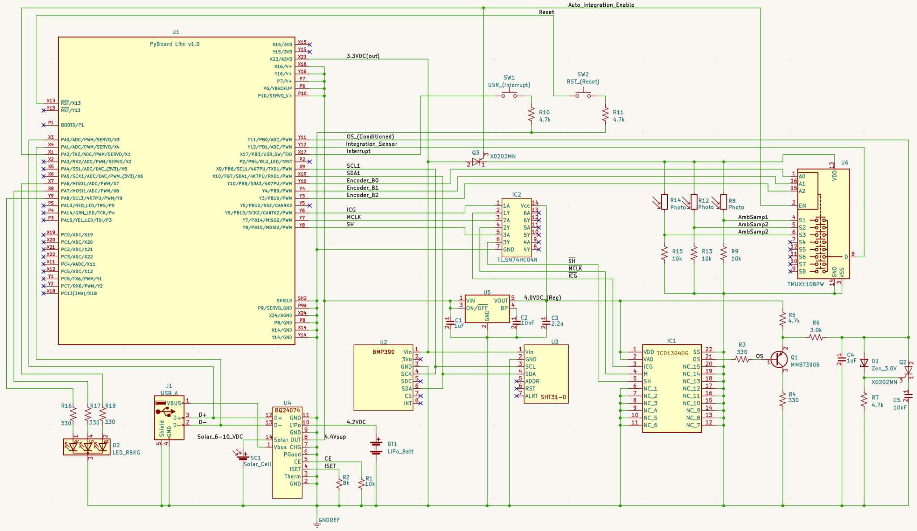
Figure 5 : The electronic schematic showing components for the spectrometer.
We have selected a dual-core ARM processor and MicroPython microcontroller to improve the spectrometer electronics unit's efficiency, control, and power consumption. It will have an intelligent power module that selects active voltage sources to conserve and charge a lithium polymer battery. It will have expandable flash memory that will store data, including near-infrared wavelengths, temperature, humidity, barometric pressure, altitude, and inclination angle. The optical assembly will be isolated from temperature-induced aberrations and noise in a separate chamber housing the control and power modules. The system will optimize exposure in changing light conditions by adjusting the electronic shutter and readout time of the Toshiba Linear Array through an auto Integration-Time module that consumes no power when not in use. The Toshiba TCD1304DG analog output signal will be optimized and limited by a dedicated circuit to help amplify the signal.

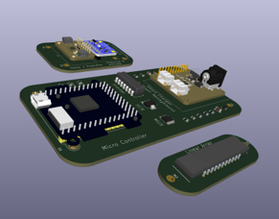
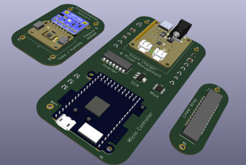
The preceding images showcase a 3-dimensional rendering of the above PCB design. A hyperspectral response curve will be provided by the current linear array for wavelengths in the Near Infrared (NIR) range, but we have the ability to include design space for a second chip for future developments with added range in hyperspectral responsivity.​ ​The design is centered around the optical assembly, which will focus gradated and collimated light onto the Linear Array (Toshiba TCD1304DG). The final dimensions of the three thermally isolated PCBs are being refined in tandem with the Mechanical Engineering team we are currently working with.
Figure 7 : The electronic showing components for the spectrometer.
Figure 6 : The electronic showing components for the spectrometer.
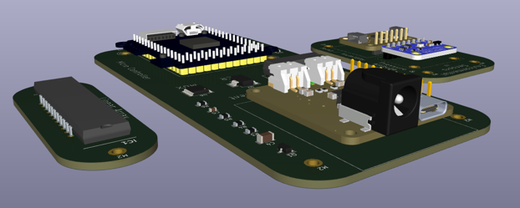
Figure 8 : The electronic showing components for the spectrometer.

Conclusions
As the first half of this capstone project comes to a close, we now have a clear path forward as to what needs to be done next, and when. There are still refinements to the linear array analog output conditioning circuit to be finalized. The exact dimensions of the PCBs can be handed over to the ME team so they can be integrated into the electrical and optical enclosures. Coding of all the major functions as well as sub-functions can now begin to be implemented and orchestrated. Once our electrical design has been tested and verified, we will send out the fabrication request for the custom PCB to be manufactured. We will do all of the surface-mount micro soldering ourselves in-house.
After the board and electronics are assembled, calibration and characterization of operation will commence in both controlled lab environments, as well as outdoors for a minimum of five days, will be implemented. The calibration will use a traceable light source in a temperature controlled environment to catalog the correction factors and improve the overall accuracy.
Thus far, we have spent much time in deliberation over additional funding for the purchase of a higher-end linear array that can be built into the system. Eventually this basic infrastructure will house two linear arrays to allow for hyperspectral response from 350 nm to 2500 nm. Although TEEM Radiance will not have time to fully implement this design, we are paving the way for future capstone projects to complete the ultimate design capabilities. A smart power handling unit that will select the strongest voltage source available before using battery power will send power to all the electronics. A solar panel will provide supplemental power for charging and for running electronics when available. The device will utilize the USB power bus when available.
A dedicated low-noise 4.0 V linear voltage regulator is used to power the linear array and its dedicated inverter IC. Several environmental sensors are implemented over the serial addressable I2C protocol to save pin space. These sensors are referenced by the same 3.3 V from the PyBoard to maintain the accuracy of sensor readings. An auto integration circuit can be enabled to auto adjust for the exposure time of the linear array. When disabled this circuit will draw no power. Two user interface buttons, a USB 2.0 plug, as well as an RGB PWM controllable LED will serve as a quick feedback indicator to the world outside of the box. State of the microprocessor, battery, data, and more will all be encoded into various colors and light patterns for a quick relay of spectrometer conditions to the user. We will move this project to completion with as much parallelism as possible. Our goal is to complete this build with enough time to thoroughly test and refine the spectrometer's performance.

Bibliography
[1] J. R. Vanderveen, B. Martin, and K. J. Ooms, “Developing Tools for Undergraduate Spectroscopy: An Inexpensive Visible Light Spectrometer,” Journal of chemical education, vol. 90, no. 7, pp. 894–899, 2013, doi: 10.1021/ed300396x.
[2] N. Savage, “Spectrometers,” Nature photonics, vol. 3, no. 10, pp. 601–602, 2009, doi: 10.1038/nphoton.2009.185.
[3] M. Faraji-Dana, E. Arbabi, A. Arbabi, S. M. Kamali, H. Kwon, and A. Faraon, “Compact folded metasurface spectrometer,” Nature communications, vol. 9, no. 1, pp. 4196–8, 2018, doi: 10.1038/s41467-018-06495-5.
[4] S. Meerdink et al., “Plant species’ spectral emissivity and temperature using the hyperspectral thermal emission spectrometer (HyTES) sensor,” Remote sensing of environment, vol. 224, pp. 421–435, 2019, doi: 10.1016/j.rse.2019.02.009.
[5] F. Thomas, R. Petzold, C. Becker, and U. Werban, “Application of Low-Cost MEMS Spectrometers for Forest Topsoil Properties Prediction,” Sensors (Basel, Switzerland), vol. 21, no. 11, p. 3927–, 2021, doi: 10.3390/s21113927.

